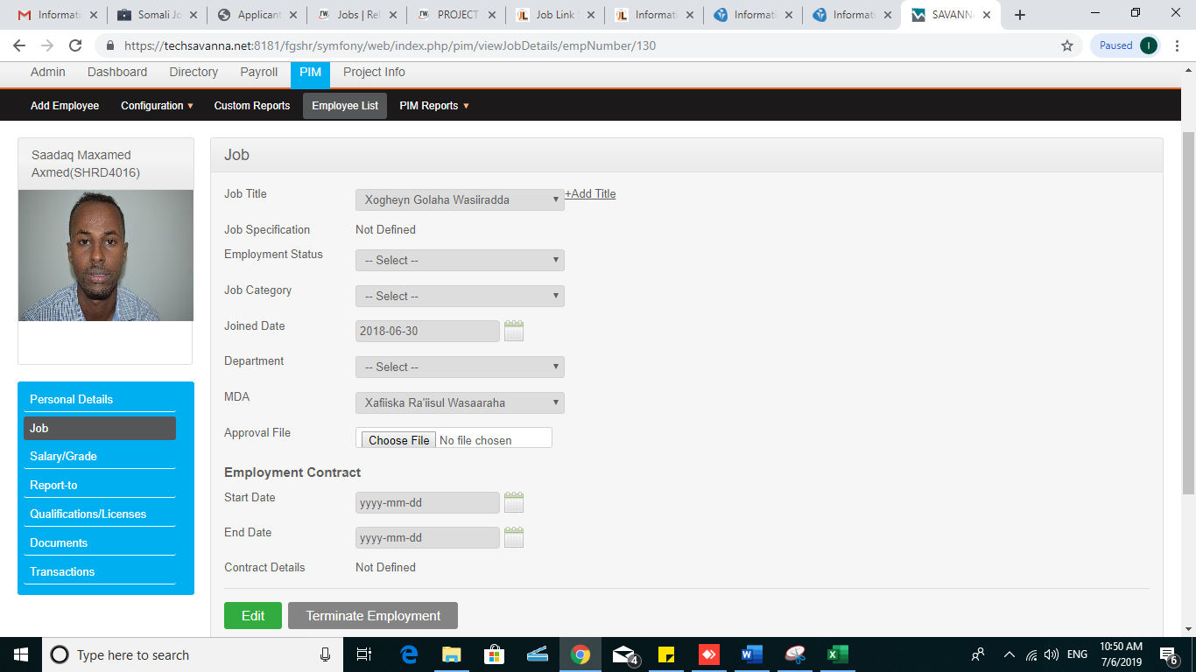

Figure 1.0: the above employee (SHRD 4016) is assigned MDA as it’s in the jobs section and still in the recruitment report it shows in the Hayádda/MDA not given as shown in figure below

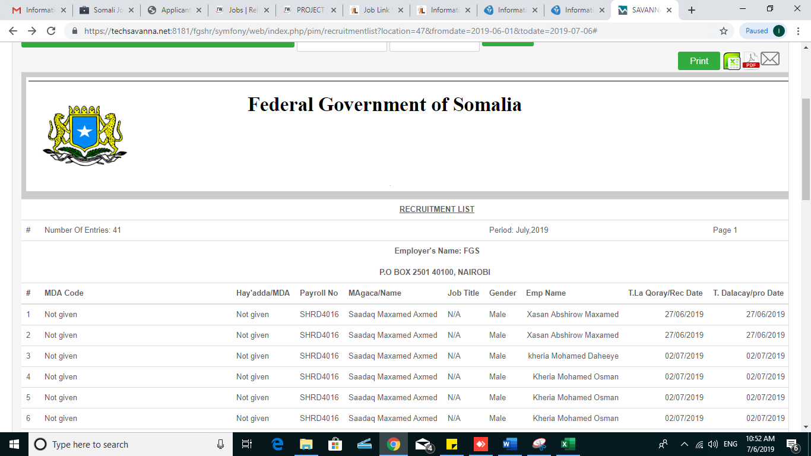

Figure1.1:- recruitment report

Here you see two name fields in the recruitment list report and have different values with same SHRD4016 (please remove the (emp name) or (MAgaca/Name) fields) and adjust all the report as their name means.

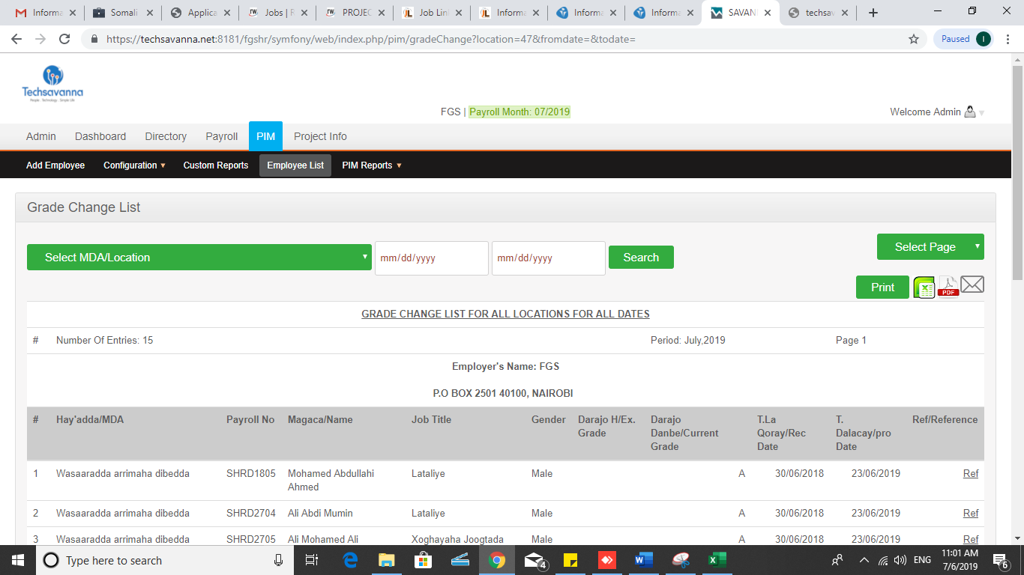

Figure1.2:- in the grade change list report no searching option by MDA location only or by date only without selecting any MDA as well as there is no download as excel file per MDA completely.

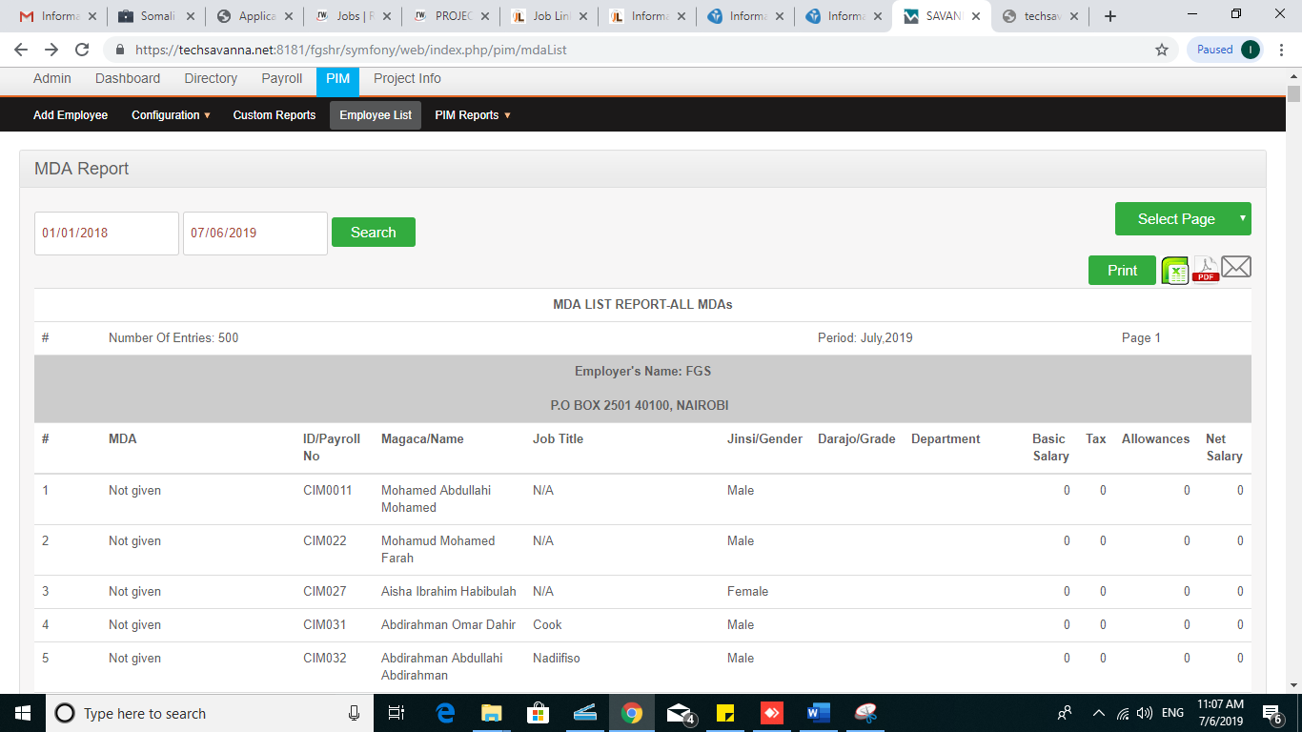

Figure 1.3:- no download option for all pages in the excel format the download option per page is still for all the pages, also the summery of all MDA it will not show in the downloaded excel file

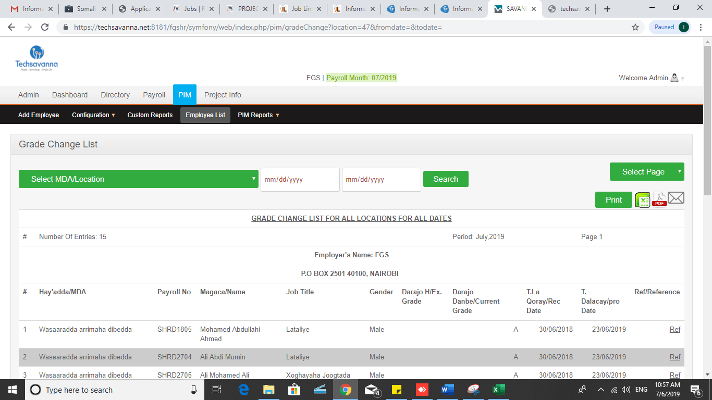

Figure 1.4:- if there is any update in the grade change it will not appear in this section please fix this.

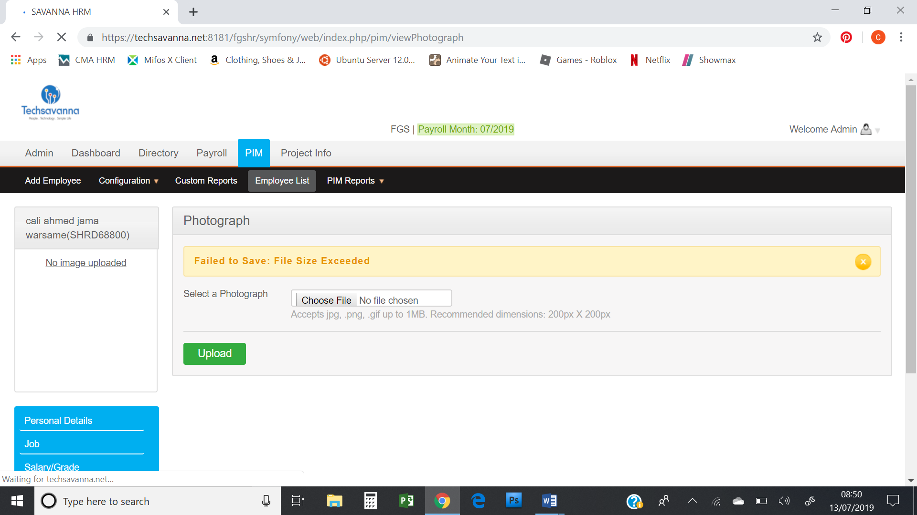

Figure 1.5:- can’t upload photo directly due to size

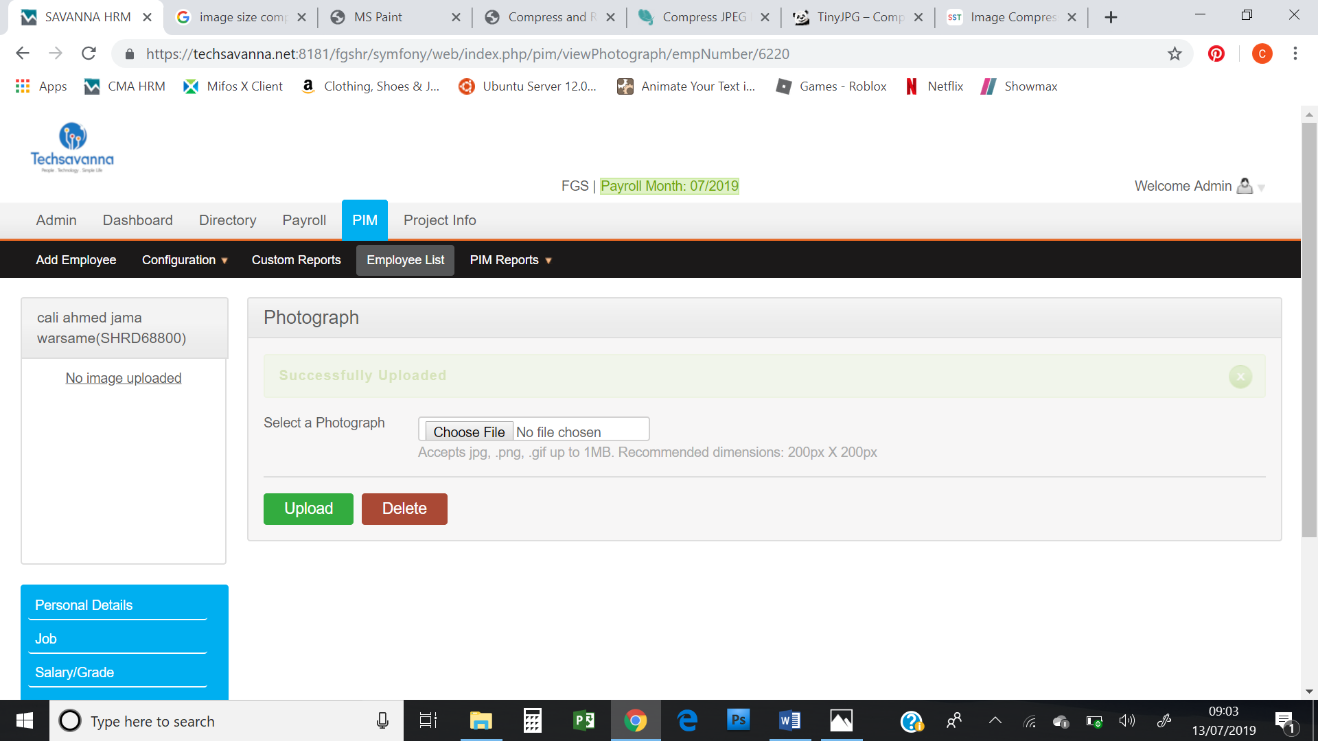

Figure 1.6:- after compressed the image less than 1 MB it shows successfully uploaded and it will display nothing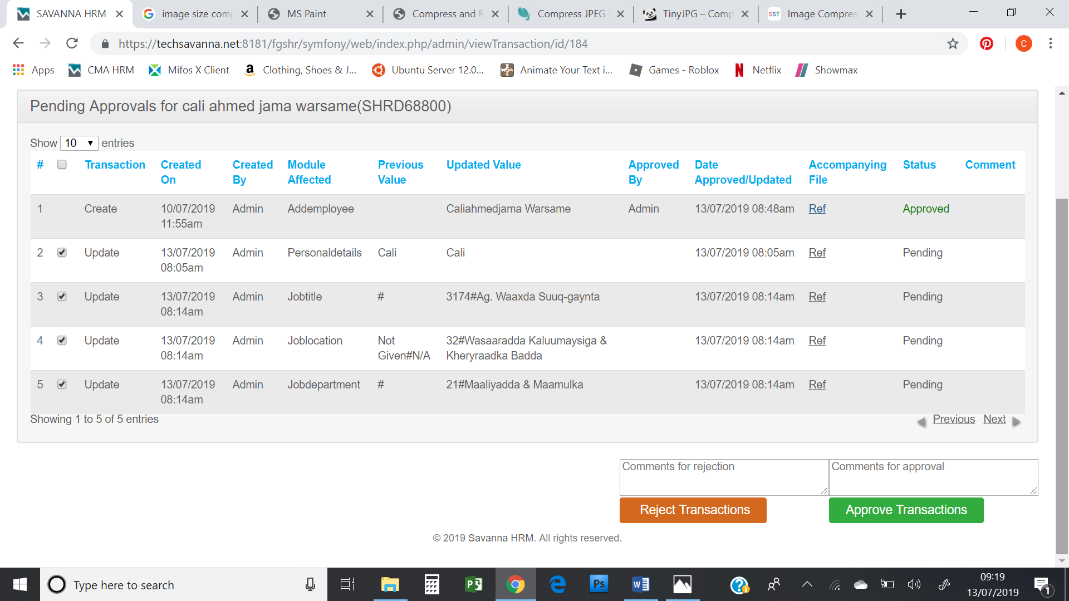

Figure1.7:- please add select all check box option in order to process all the transactions at once when verified

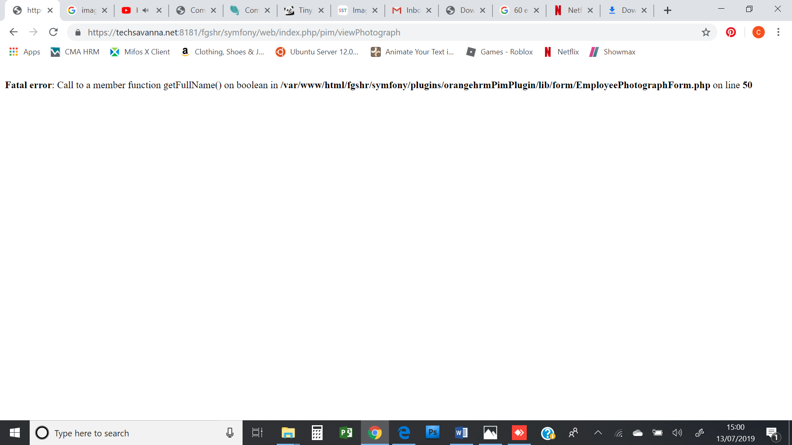

Figure 1.8:- viewing photograph sometimes shows the above fatal error

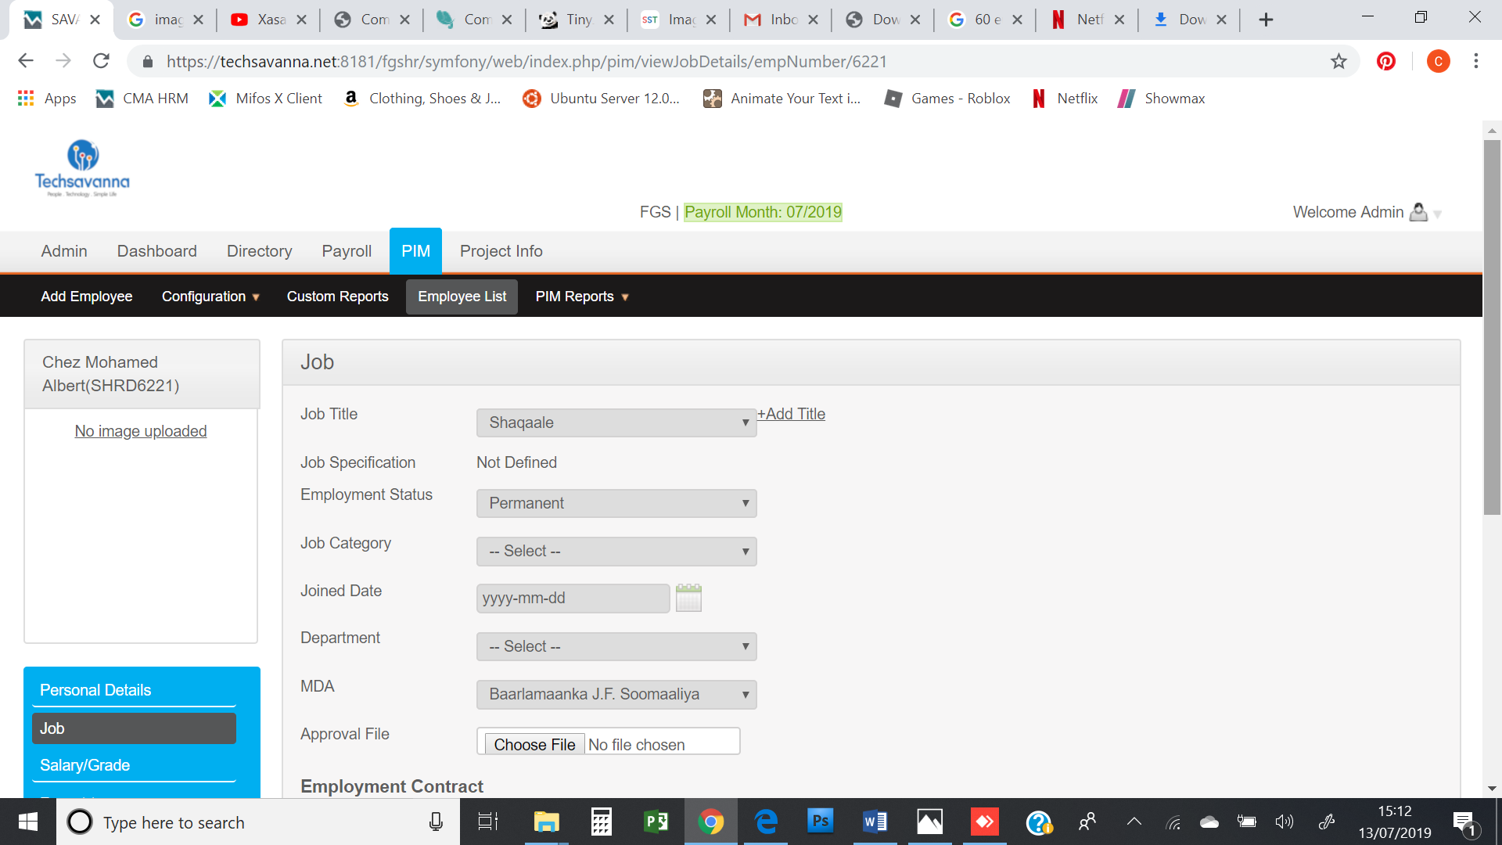

Figure 1.9:- the above employee of SHRD6221 is assigned MDA and Job Title still in the figure below shows no MDA and job Title

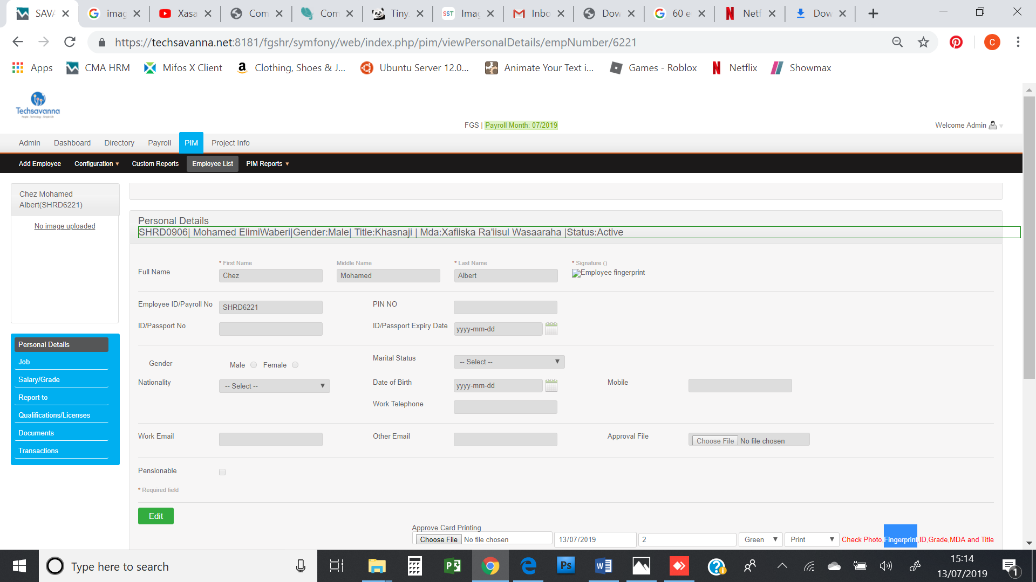

NB. 1. Please adjust all the report with their header and also content as some of the report links are misplaced and did not show the excepted value as they are.

2. direct printing of the card we still have trouble please retry to address